4.1) PROGRESS – REPRO – SCREEN VIEW

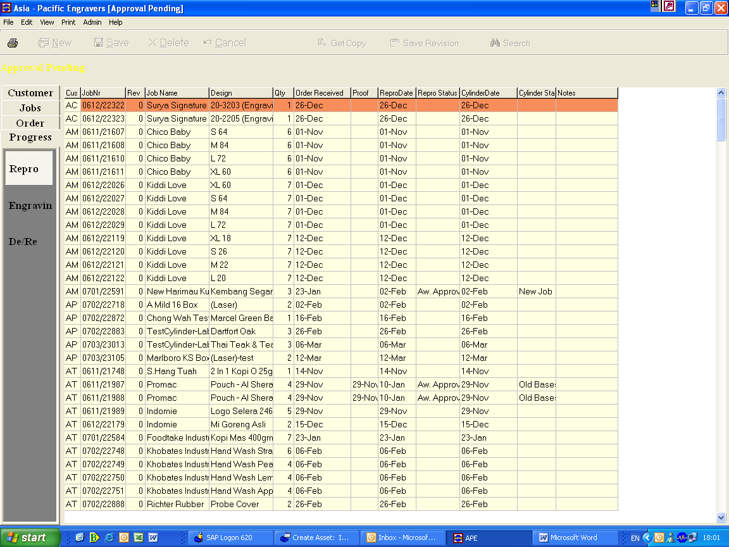

4.2) PROGRESS – ENGRAVING – SCREEN VIEW

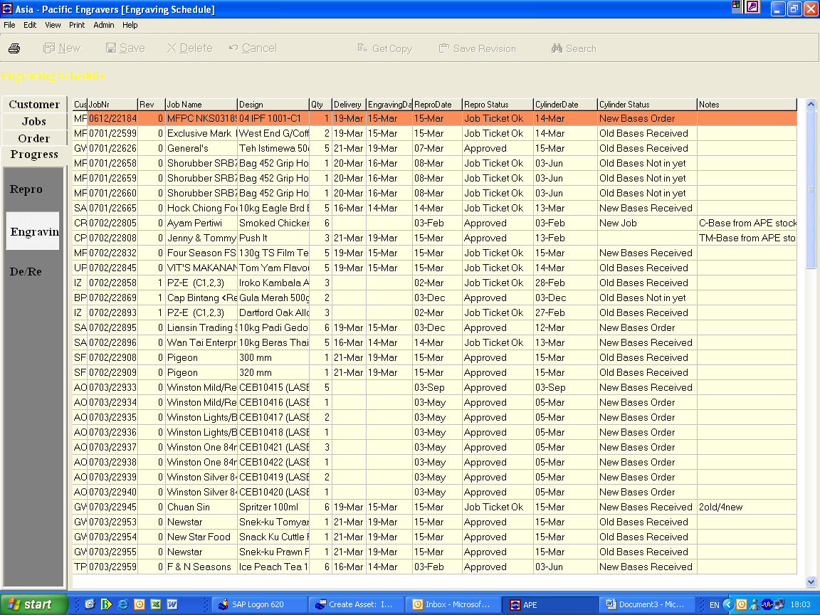

4.3) PROGRESS – DE/RE – SCREEN VIEW

